

**UNIVERSITY OF GREENWICH**

COMP1649

–

Human Computer Interaction and Design

Coursework

Interaction and Design

|  |  |
| --- | --- |
| Student | **Tran Chi Huynh** |
| ID number | **001353300** |
| Supervisor | **Bui Dang Ha Phuong** |
| Student submission date | **November 24th, 2023** |
| Word count | **3256 words** |

**Contents**

**1. Introduction 1**

**2. Background literature 1**

**2.1. HCI Research 1**

**2.2. HCI Theory 2**

**2.2.1. Interaction design principles and interaction design patterns 2**

**2.2.2. Investigation in cognitive psychology 2**

**2.2.3. Interaction design theory 3**

**3. Design Process 4**

**3.1. Conceptual Design 4**

**3.1.1. Types of interaction and modes of interaction 4**

**3.1.2. User requirement 5**

**3.1.3. Problem statement and design solutions 5**

**3.1.4. Hierarchical model 5**

**3.1.5. Conceptual model 6**

**3.2. Design principles 8**

**4. Prototype 9**

**4.1. Low-fidelity prototype 9**

**4.2. Mid-fidelity prototype 12**

**4.3. Physical Design 20**

**5. Research Study 21**

**6. Conclusion 23**

**References 25**

**Appendices 1 - The questionnaires in the Diving Tracking project’s survey 26**

**Appendices 2 - Analyze the results of the questions in the survey and draw conclusions for each hypothesis that has been raised. 28**

**Appendices 3 - Ten heuristics for user interface design outlined by Nielsen 32**

**List of Tables**

**Table 1: Metaphors used in Diving Tracking project 7**

**Table 2: Hypothesis & Questions 23**

**List of Figures**

**Figure 1: iDiveblue 1**

**Figure 2: Shearwater Teric 1**

**Figure 3: DiveMate 2**

**Figure 4: Hierarchical model 5**

**Figure 5: Conceptual model of Diving Tracking project 6**

**Figure 6: Low-fidelity prototype of Signup 9**

**Figure 7: Low-fidelity prototype of Login 9**

**Figure 8: Low-fidelity prototype of Homepage 10**

**Figure 9: Low-fidelity prototype of Taking photos/videos and Tracking activities 10**

**Figure 10: Low-fidelity prototype of Setting 11**

**Figure 11: Low-fidelity prototype of Profile 11**

**Figure 12: The interface of Sign-up 12**

**Figure 13: Demonstration of the Feedback Design Principle 12**

**Figure 14: The interface of Log-in 13**

**Figure 15: Demonstration of the Affordance Design Principle 13**

**Figure 16: The interface of Tracking List 14**

**Figure 17: The interface of Tracking List when clicking on the image 14**

**Figure 18: The interface of the Tracking List, when clicking on a tracking, the application will show a picture of that tracking. 15**

**Figure 19:Demonstration of the Visibility Design Principle 15**

**Figure 20: Demonstration of the Constraints Design Principle 16**

**Figure 21: The interface of Diving Tracking 16**

**Figure 22: Demonstration of the Mapping Design Principle 17**

**Figure 23: The interface of Photos/Videos Figure 24: Deleting the photo or video 17**

**Figure 25: The interface of Profile 18**

**Figure 26: The interface of Setting tab 18**

**Figure 27: The interface of About app 19**

**Figure 28: The interface of Help users 19**

**Figure 29: Demonstration of the Consistency Design Principle 20**

**Figure 30: Physical Design 20**

**Figure 31: Question 1 of Hypothesis 1 28**

**Figure 32: Question 2 of Hypothesis 1 28**

**Figure 33: Question 3 of Hypothesis 1 29**

**Figure 34: Question 4 of Hypothesis 1 29**

**Figure 35: Question 1 of Hypothesis 2 30**

**Figure 36: Question 2 of Hypothesis 2 30**

**Figure 37: Question 3 of Hypothesis 2 30**

**Figure 38: Question 4 of Hypothesis 2 31**

**Figure 39: Visibility of system status of Diving Tracking project 32**

**Figure 40: Match between system and the real world of Diving Tracking project 32**

**Figure 41: User control and freedom of Diving Tracking project 33**

**Figure 42: User control and freedom of Diving Tracking project 33**

**Figure 43: Consistency and standards of Diving Tracking project 34**

**Figure 44: Consistency and standards of Diving Tracking project 34**

**Figure 45: Error prevention of Diving Tracking project 35**

**Figure 46: Error prevention of Diving Tracking project 35**

**Figure 47: Recognition rather than recall of Diving Tracking project 36**

**Figure 48: Recognition rather than recall of Diving Tracking project 36**

**Figure 49: Flexibility and efficiency of use of Diving Tracking project, turn on the feet-to-meter and kelvin-to-celsius conversion modes 37**

**Figure 50: Flexibility and efficiency of use of Diving Tracking project, turn on the feet-to-meter and kelvin-to-celsius conversion modes 37**

**Figure 51: Flexibility and efficiency of use of Diving Tracking project, turn off the feet-to-meter and kelvin-to-celsius conversion modes 38**

**Figure 52: Flexibility and efficiency of use of Diving Tracking project, turn off the feet-to-meter and kelvin-to-celsius conversion modes 38**

**Figure 53: Aesthetic and minimalist design of Diving Tracking project 39**

**Figure 54: Help users recognize, diagnose, and recover from errors of Diving Tracking project 39**

**Figure 55: Help and documentation of Diving Tracking project 40**

**Figure 56: Help and documentation of Diving Tracking projec 40**

# Introduction

This project introduces a new diving app and device developed using advanced technology to improve the diving experience and ensure safety for users. The app and device will connect to each other, allowing users to accurately and reliably track depth, dive time, and pressure. Underwater photography and video recording features will help users preserve memorable moments from each dive. Next, we will discuss the structure of this report, which consists of the following sections: introduction, background literature, design process, prototype, research study, and conclusion. The background literature and design process are the most important sections, as they provide the foundation for the development of the product and prototype. A prototype is the embodiment of the product's design concept, and a research proposal is an evaluation of the product's feasibility. Finally, the introduction and conclusion provide an overview and conclusion of the entire assignment.

# Background literature

# HCI Research

Technological advancements in diving have brought us innovative applications and devices like iDiveblue, which enhance the diving experience and ensure safety. iDiveblue is a mobile app that connects to a wearable device on the head to monitor depth and pressure, providing accurate information. It can also capture underwater photos and videos, preserving memorable moments from each dive (By Laura Foley, 2022).



Figure 1: iDiveblue[1]

Shearwater Teric: Head-mounted dive computer with precise depth and pressure monitoring, underwater photography and video recording. (Mark Evans, 2022).



Figure 2: Shearwater Teric[2]

DiveMate: Multifunctional dive app with clear depth and pressure monitoring, underwater photography, and video recording. (Divernet, 2020).

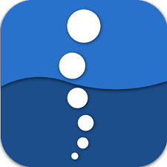

Figure 3: DiveMate[3]

The upcoming diving app and device will offer a superior diving experience by combining advanced technology and photography capabilities. The head-mounted device will accurately and reliably monitor depth and pressure, while the underwater photography and video recording features will help preserve and share stunning moments. This app and device goes beyond simply monitoring and recording information to create engaging and memorable experiences.

# HCI Theory

# Interaction design principles and interaction design patterns

* **Interaction Design:** Interaction design crafts seamless connections between users and products. By understanding user needs and aspirations, interaction designers create intuitive, engaging, and enjoyable experiences (Teo Yu Siang, 2020).
* **Interaction design principles:** Interaction design principles guide designers to make informed decisions about their interfaces (Sharp, et al., 2019). Notable interaction design principles include Visibility, Feedback, Constraints, Consistency, Mapping, and Affordance (Norman, 2002)
* **Interaction design patterns:** Design patterns are a repository of accumulated design knowledge that helps designers apply fundamental principles (Sharp, et al., 2019).

**Interaction design principles applied to this coursework:** Interaction design principles played a pivotal role in shaping this coursework. Principles like Visibility, Feedback, Constraints, Consistency, Mapping, and Affordance were intentionally incorporated to enhance user experience, fostering ease of use, efficiency, and enjoyment.

# Investigation in cognitive psychology

* **Cognition:** Cognition encompasses the diverse ways we perceive, understand, and interact with the world. It includes both automatic and conscious processes, and is influenced by our environment and interactions. (Rogers, 2012) (Sharp, et al., 2019).
* **How aspects of cognitive psychology affect interaction design**
  + **Attention:** Attention allows us to focus on specific things while ignoring distractions. Limited by our cognitive capacity, we cannot focus on everything at once. Instead, we prioritize information based on our goals and the salience of stimuli. This process enables us to engage with relevant information while minimizing the influence of irrelevant stimuli (Sharp, et al., 2019).
  + **Perception:** Perception is an intricate process that transforms raw sensory information into meaningful experiences. It involves a complex interplay of our senses and cognitive abilities, allowing us to interpret and interact with the world around us (Roth & Frisby, 1986). In the realm of interaction design, it is crucial to present information in a way that aligns with human perception, ensuring that users can easily grasp and process the intended message (Sharp, et al., 2019).
  + **Recognition:** Recognition is the ability to identify and remember previously encountered information (Sharp, et al., 2019).
  + **Memory:** Memory stores our experiences, enabling us to recall information later. It empowers us to learn and make informed decisions. (Sharp, et al., 2019).

**Cognitive psychology principles applied to this coursework:** Cognitive psychology principles can make the diving tracking app safer and more efficient by helping users easily grasp and retain important information. The app uses design elements like large, bold fonts, clear language, and consistent icons to help users pay attention, understand, find, and remember key dive data.

# Interaction design theory

* **Conceptual model**
  + **Definition:** A conceptual model in interaction design is a high-level overview of how a product or service will work. It helps designers understand the problem, potential solutions, and user interactions. This model guides the design process and ensures the final product meets user expectations. (Norman, 2002).
  + **Metaphors:** Metaphors are a key part of conceptual models, helping us understand abstract ideas by comparing them to something familiar. (Norman, 2002).
* **Prototypes**
  + **Definition:** Prototypes are tangible models of design ideas, allowing stakeholders to test and refine them before final development (Norman, 2002).
  + **The main types of prototypes**
    - **Low - fidelity prototypes:** Lo-fi prototypes are quick and simple models of design ideas that help gather feedback and refine concepts early on. They lack the polish of high-fidelity prototypes but effectively convey the core structure, content, and user flow (Sharp, et al., 2019).
    - **Mid - fidelity prototypes:** Mid-fidelity prototypes bridge the gap between low-fi and high-fi prototypes, offering a more refined and interactive representation of the final product (Sharp, et al., 2019).
    - **High - fidelity prototypes:** Hi-fi prototypes are the most polished stage of prototyping, closely resembling the final product in appearance, functionality, and user experience (Sharp, et al., 2019).
* **The types of prototypes applied to this coursework:** Low-fidelity prototyping facilitates rapid ideation and early feedback collection, enabling iterative design refinement. Mid-fidelity prototyping supports deeper understanding of user needs and preferences, empowering the creation of user-friendly, aesthetically pleasing, and engaging products.

# Design Process

# Conceptual Design

# Types of interaction and modes of interaction

* **The main types of interaction**
  + **Instructing:** Instruction, a core element of user-system interaction, allows users to convey their intentions and actions to the system. Effective instruction design ensures seamless interaction and goal achievement (Sharp, et al., 2019).
  + **Conversing:** Conversing, or natural language interaction, marks a shift from command-based interfaces to human-like dialogue, allowing users to interact with systems through natural language (Sharp, et al., 2019).
  + **Manipulating:** Manipulation in user interaction involves user actions and techniques to control, interact with, and modify elements within a system (Sharp, et al., 2019).
  + **Exploring:** Exploration in user interaction involves navigating and investigating environments to gain knowledge, understand layout, and discover new information (Sharp, et al., 2019).
* **The interaction types applied to this coursework:** The project emphasized clear instructions to guide users effectively, reducing confusion and frustration for a seamless user experience.
* **The modes of interaction**
  + **Touch:** Touch interaction, common on devices like smartphones and tablets, lets users interact with systems directly and intuitively using their fingers or other touch-sensitive tools (Jewitt, et al., 2019).
  + **Voice:** Voice interaction, or voice UI, has revolutionized human-computer interaction by enabling natural language commands, making technology more accessible and convenient for a wider range of users (Cohen, et al., 2004).
* **The interaction modes applied to this coursework:** This coursework harnessed touch interaction to create a visually engaging experience, fostering natural and intuitive user engagement.

# User requirement

Following the completion of interaction design research, we will begin implementing two key modules for the Diving Tracking project.

* Taking photo/video under water
* Tracking diving activities

# Problem statement and design solutions

* **Problem:** Design a prototype for a mobile application to assist users in taking photos or videos underwater and tracking diving activities
* **Solution:** To solve the problem above, the system will include the following functions:
  + **Tracking diving :** add a new tracking (start, pause, resume, stop diving tracking, and monitor depth, time, air in tank and temp), view (date, depth, time, air, and temp), rename, search, delete, and sort tracking
  + **Taking photo/video:** take, view, and delete the photo or video
  + **Setting:** Change the password, edit the profile, view about app, help users, turn on or off Bluetooth, GPS, and Wi-Fi, and convert the unit of temp and depth
  + **Authentication:** Sign in, sign up(view terms & conditions), and log out.

# Hierarchical model

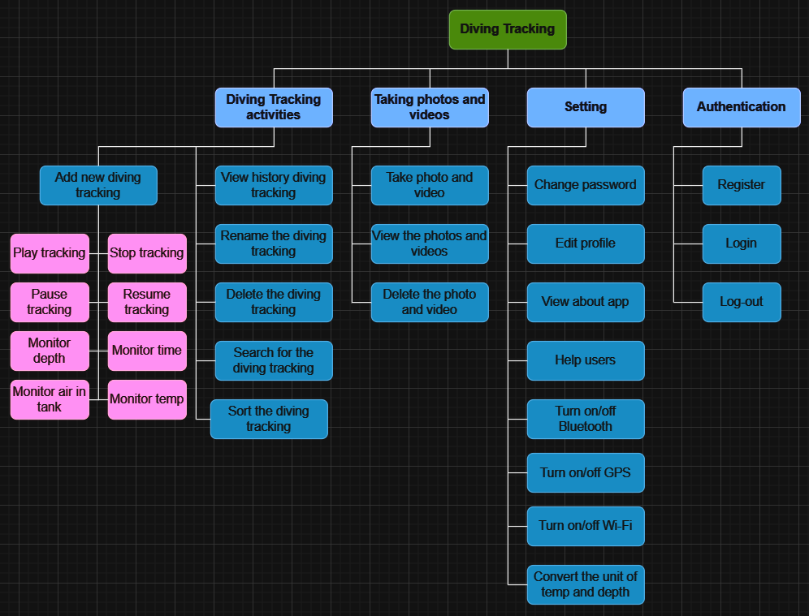

Figure 4: Hierarchical model

Below are the functions in the following 4 modules (Figure 4):

* + **Tracking diving activities:** add a new tracking (start, pause, resume, stop diving tracking, and monitor depth, time, air in tank and temp), view (date, depth, time, air, and temp), rename, delete, search, and sort tracking
  + **Taking photo/video:** take, view, and delete the photo or video
  + **Setting:** Change the password, edit the profile, view about app, help users, turn on or off Bluetooth, GPS, and Wi-Fi, and convert the unit of temp and depth
  + **Authentication:** Sign in, sign up(view terms & conditions), and log out.

# Conceptual model

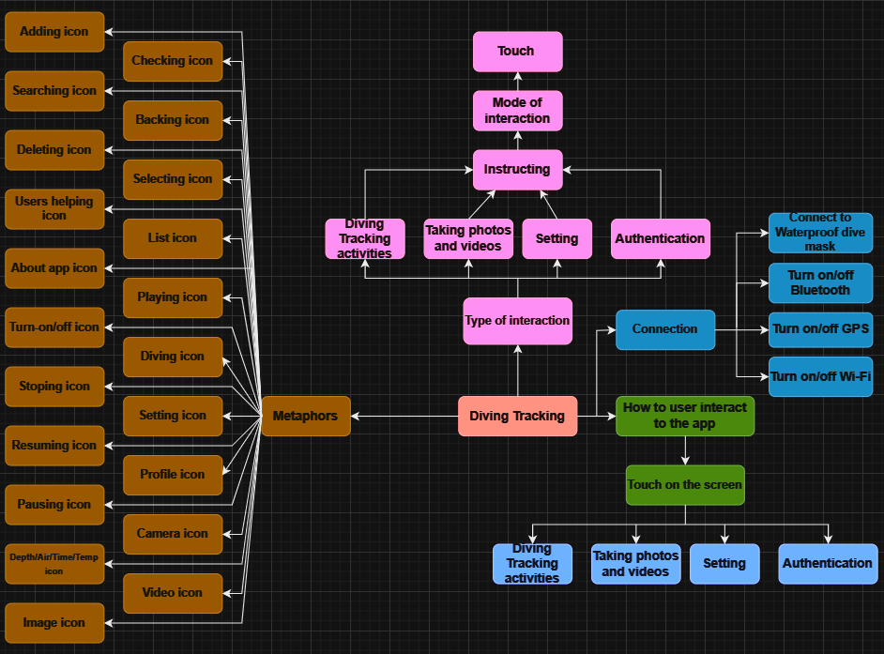

Figure 5: Conceptual model of Diving Tracking project

Below, we will elucidate some of the key components depicted in Figure 5:

* + **Metaphors:** Comprising icons utilized in design.
  + **Type of interaction:** Involving 4 modules with interaction directed towards these modules through touchscreen gestures.
  + **Connection:** Involving external connections.

Table 1: Metaphors used in Diving Tracking project

|  |  |  |
| --- | --- | --- |
| **No** | **Metaphors** | **Meaning** |
| 1 | Deleting icon | Delete the diving tracking, photos, or videos |
| 2 | Selecting icon | Select all diving tracking |
| 3 | Checking icon | Check the diving tracking |
| 4 | Searching icon | Search the diving tracking |
| 5 | Adding icon | Add the diving tracking |
| 6 | Backing icon | Back to a page |
| 7 | Temp icon | Show temperature |
| 8 | Depth icon | Show depth |
| 9 | Air icon | Show air |
| 10 | Time icon | Show time |
| 11 | Video icon | Record the video |
| 12 | Pausing icon | Pause the video |
| 13 | Resuming icon | Resume the video |
| 14 | Playing icon | Play the video |
| 15 | Stopping icon | Stop the video |
| 16 | Camera icon | Take the photo |
| 17 | About app icon | Show about app |
| 18 | Users helping icon | Show users helping |
| 19 | List icon | Show tracking list tab |
| 20 | Image icon | Show photo and video library tab |
| 21 | Diving icon | Show diving tracking tab |
| 22 | Profile icon | Show profile tab |
| 23 | Setting icon | Show setting tab |
| 24 | Turn-on/off icon | Turn on/off the camera |

# Design principles

According to (Norman, 2002), the design principles:

* **Visibility:** Visibility, or discoverability, ensures users can easily find and understand product features, affecting navigation, interaction, and task completion.
* **Feedback:** Feedback bridges the gap between users and systems, providing status updates and guiding actions for effective interaction.
* **Constraints:** Design constraints restrict user interactions to promote usability and guide efficient task completion.
* **Mapping:** Design mapping aligns controls with actions, promoting predictable and consistent user interactions.
* **Consistency:** Consistency in interface design promotes a harmonious flow of interactions and visual elements for seamless user experiences.
* **Affordance:** Affordances in design guide users towards appropriate interactions. Subtle cues suggest how to engage with a system, leading to a seamless user experience.
* **The design principles will be integrated in the design :** This design incorporates all 6 design principles above.
* **Visibility:** All essential elements and features must be clear and easily perceivable, utilizing appropriate color contrast and spacing. Additionally, employ consistent icons and labels.
* **Feedback:** Provide immediate and tangible feedback for user actions.
* **Constraints:** Issue notifications prompting user reauthentication before executing functions that impact the application's data.
* **Mapping:** Employ icons that correspond appropriately to the real world.
* **Consistency:** Maintain coherence in terminology, labels, and icons, and apply consistent visual styles.
* **Affordance:** Utilize familiar shapes, sizes, and textures.

Applying these principles will make the app easier to use and safer for users. These evidences will be presented in *Section 4.2. Mid-fidelity Prototype*.

# Prototype

# Low-fidelity prototype

Here are the low-fidelity designs created for the "Daving Tracking" application: Figure 6 - 11

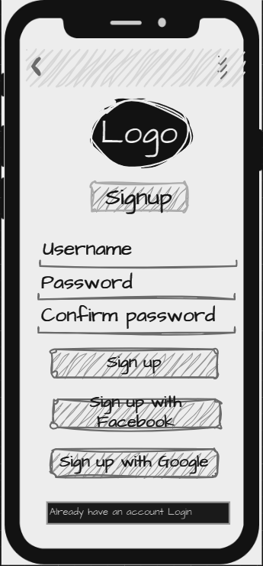

Figure 6: Low-fidelity prototype of Signup

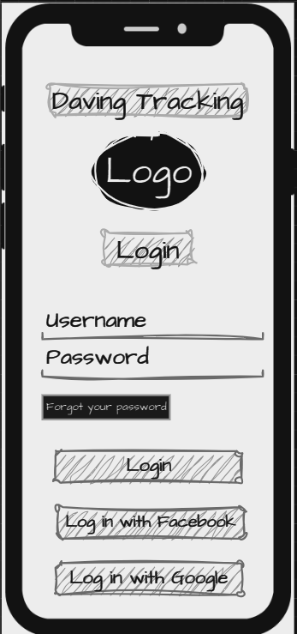

Figure 7: Low-fidelity prototype of Login

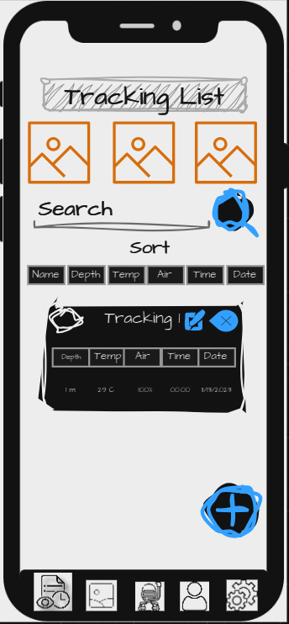

Figure 8: Low-fidelity prototype of Homepage

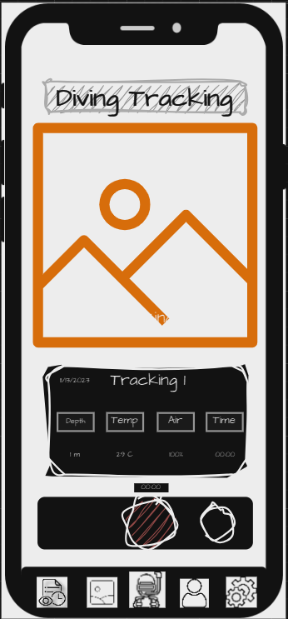

Figure 9: Low-fidelity prototype of Taking photos/videos and Tracking activities

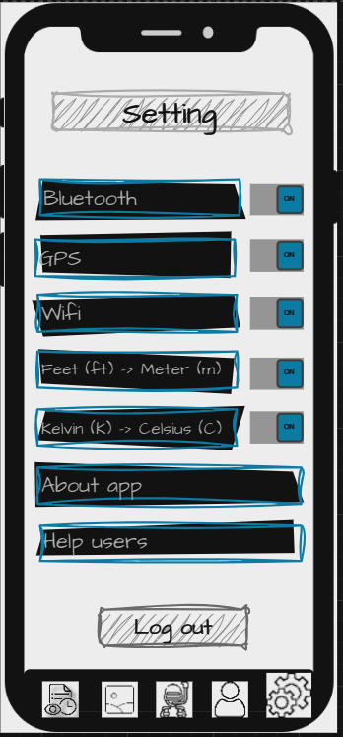

Figure 10: Low-fidelity prototype of Setting

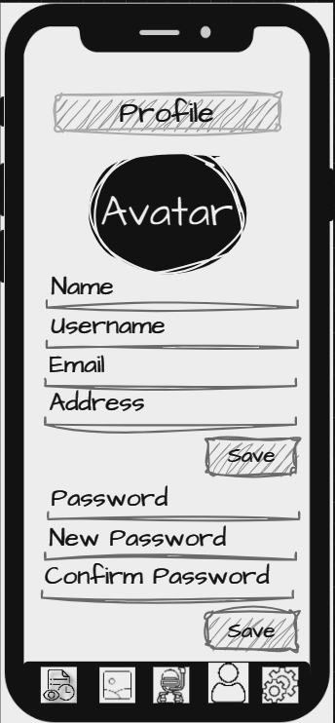

Figure 11: Low-fidelity prototype of Profile

# Mid-fidelity prototype

**The interface of Sign-up:** The sign-up interface requires users to enter a username, password, and confirm password. Users then click "Agree" to the terms and conditions. Finally, users click the "Sign up" button to complete the sign-up process (Figure 12).

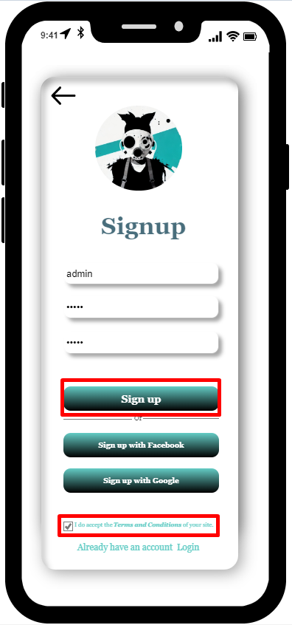

Figure 12: The interface of Sign-up

* **Feedback:** When a user enters a new password and confirms the password again, if the two entries do not match, the system will immediately display a message “Password not match” so that the user can check it in time (Figure 13).

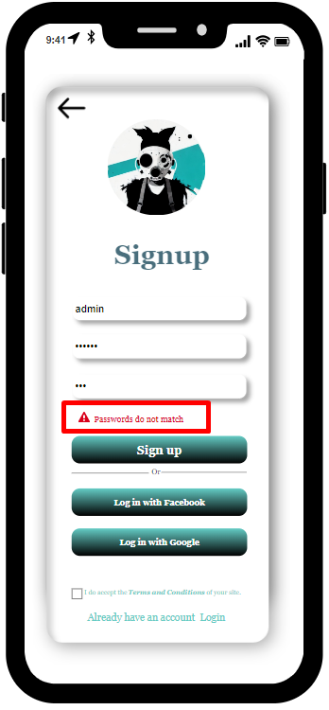

Figure 13: Demonstration of the Feedback Design Principle

**The interface of Log-in:** The login interface requires users to enter a username and password that they have previously registered. Users then click the "Log in" button. If the information entered is incorrect, an error message will be displayed and users will be prompted to enter again. Otherwise, users will be redirected to the homepage (Tracking List) (Figure 14).

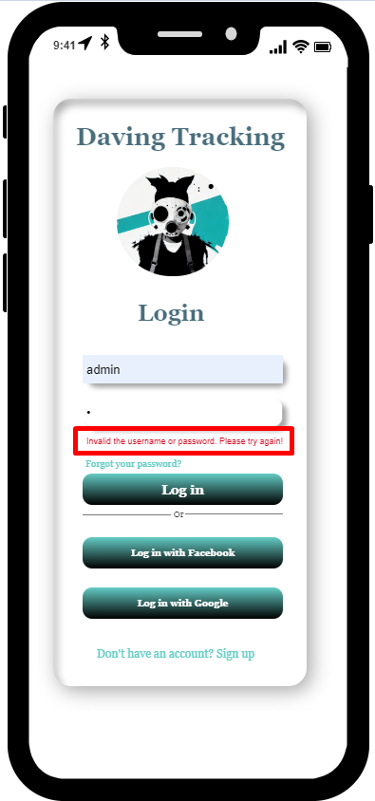

Figure 14: The interface of Log-in

* **Affordance:** The input form is intuitive, with clear and concise information labels. Users can easily understand what information they need to enter by looking at the form (Figure 15).

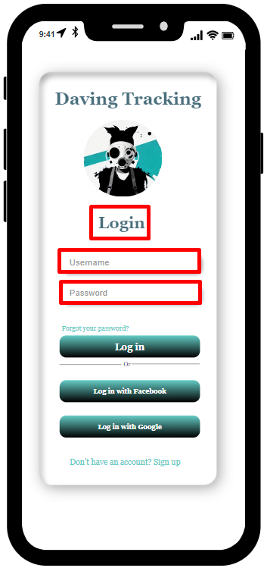

Figure 15: Demonstration of the Affordance Design Principle

**The interface of Tracking List:** Upon successful login, the Tracking List interface is displayed. The interface includes a list of tracking, each with a name, date, time, depth, temperature, air, and images. Users can click on a tracking to view the images in more detail. The interface also includes a search bar, a sorting option, a delete option, an edit option, and a new tracking option (Figure 16, 17, and 18).

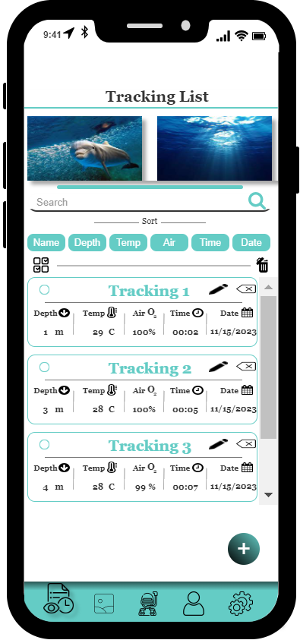

Figure 16: The interface of Tracking List

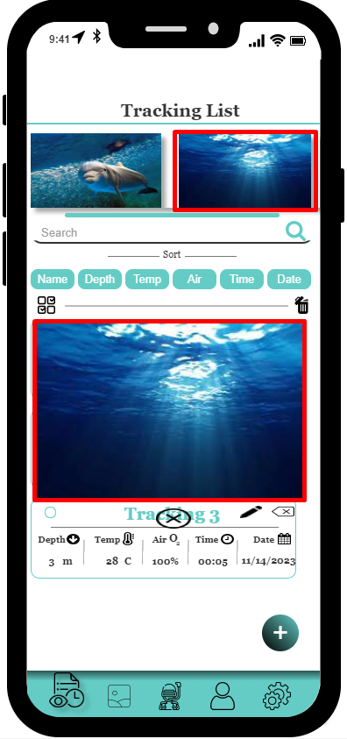

Figure 17: The interface of Tracking List when clicking on the image

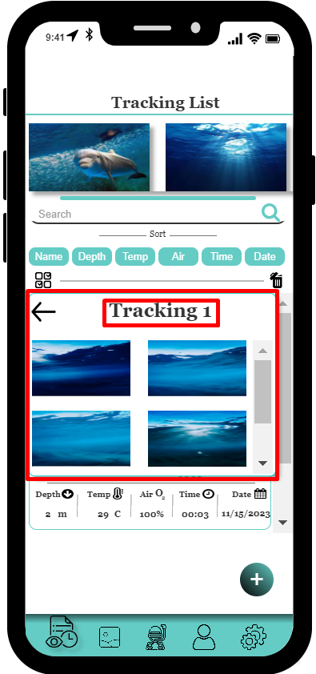

Figure 18: The interface of the Tracking List, when clicking on a tracking, the application will show a picture of that tracking.

* **Visibility:** Users can see the necessary information to complete a task. Buttons with prominent colors and large sizes help users easily identify and operate them (Figure 19).

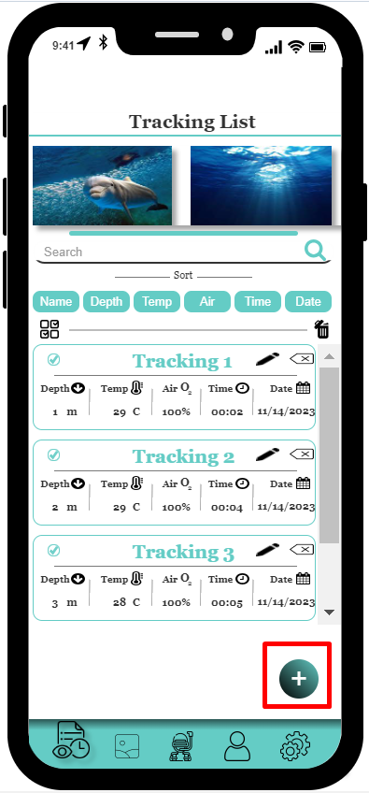

Figure 19:Demonstration of the Visibility Design Principle

* **Constraints:** When a user uses the function to delete all tracking in the list, the system will display a message requesting the user to confirm. If the user selects 'No', the program will return. If the user selects 'Yes', the program will delete all tracking in the list (Figure 20).

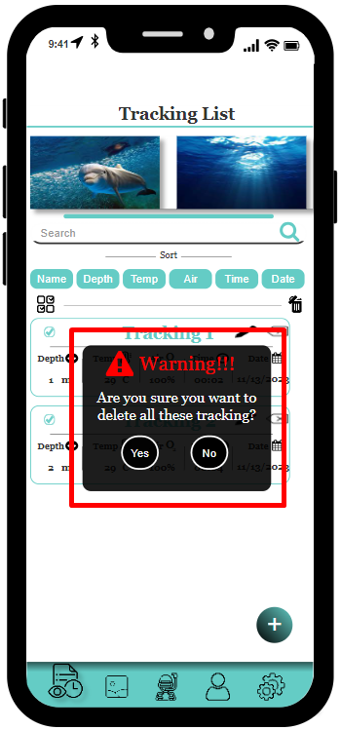

Figure 20: Demonstration of the Constraints Design Principle

**The interface of Diving Tracking:** After clicking the "+" button to add a new tracking, users will be taken to the Diving Tracking interface. At this interface, users can start a new tracking and the application will start measuring the depth, temperature, air quality, and time. The date will be taken from the current date. When users stop this tracking, the application will save the tracking and display it in the Tracking List interface. In addition, users can take photos while recording videos at this interface and the images and videos will be saved in the Photos & Videos interface (Figure 21).

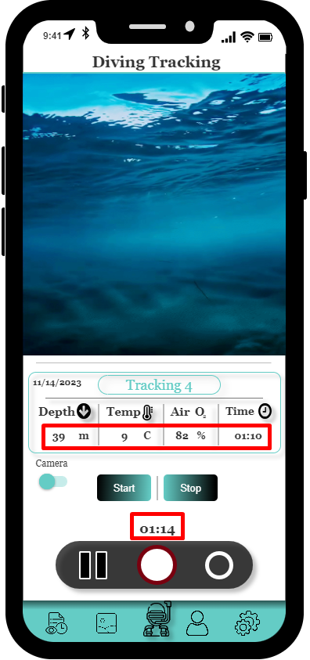

Figure 21: The interface of Diving Tracking

* **Mapping:** The system uses icons that are consistent with the real world, making it easy for users to understand and use functions when looking at icons (Figure 22).

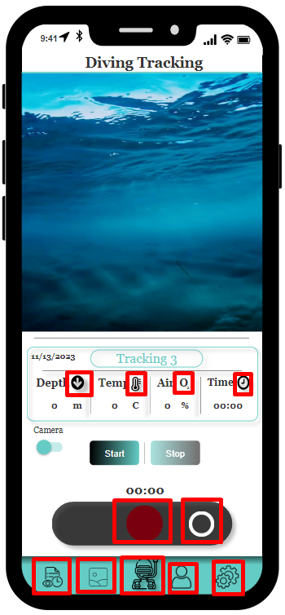

Figure 22: Demonstration of the Mapping Design Principle

**The interface of Photos/Videos:** After clicking the "Image" tab, the Photos & Videos interface will be displayed. At this interface, users can view photos and videos that were taken during the diving tracking. Users can also delete videos or photos (Figure 23 and 24).

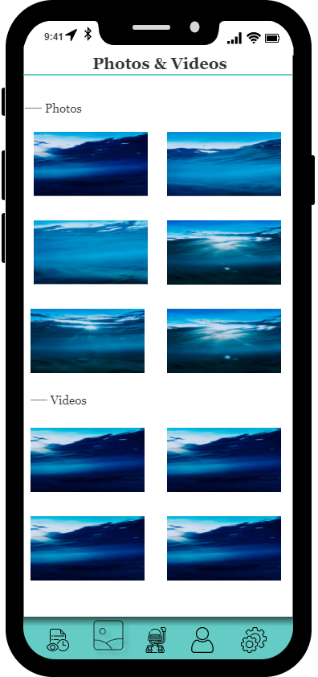 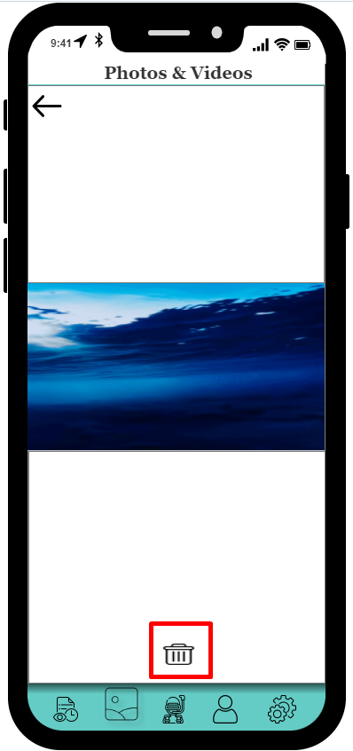

Figure 23: The interface of Photos/Videos Figure 24: Deleting the photo or video

**The interface of Profile:** The Profile interface is where the application will display the user's basic information. In addition, users can change their password if they wish (Figure 25).

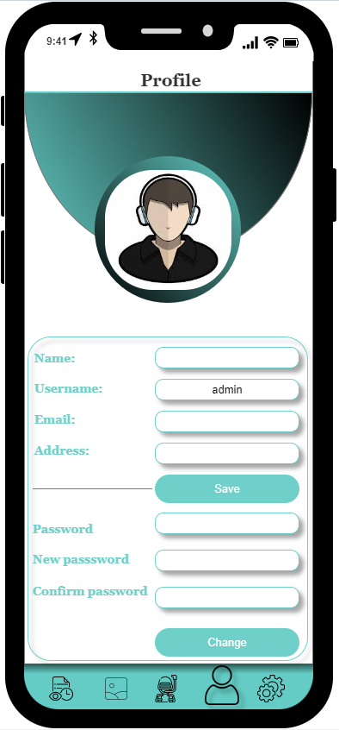

Figure 25: The interface of Profile

**The interface of Setting:** This is the Setting interface, where users can turn on or off Bluetooth, GPS, and Wi-Fi. In addition, users can convert the depth unit from feet (ft) to meters (m) or convert the temperature unit from Kelvin (K) to Celsius (C). Furthermore, they can view "About app" or "Help users". Finally, users can log out here (Figure 26, 27, and 28).

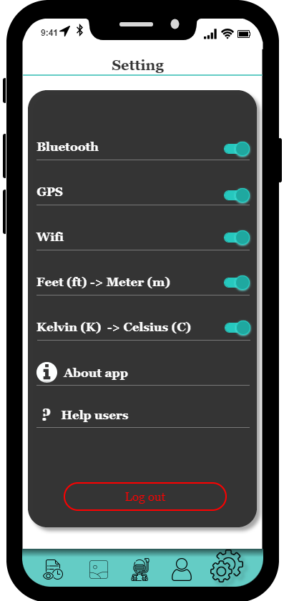

Figure 26: The interface of Setting tab

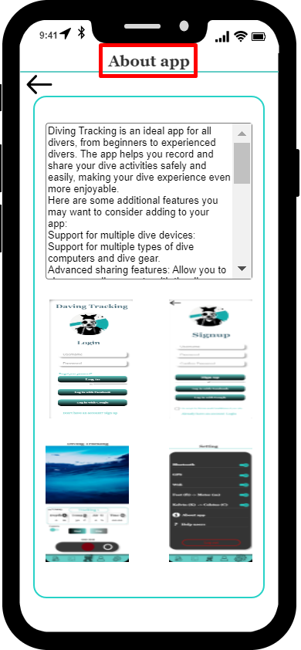

Figure 27: The interface of About app

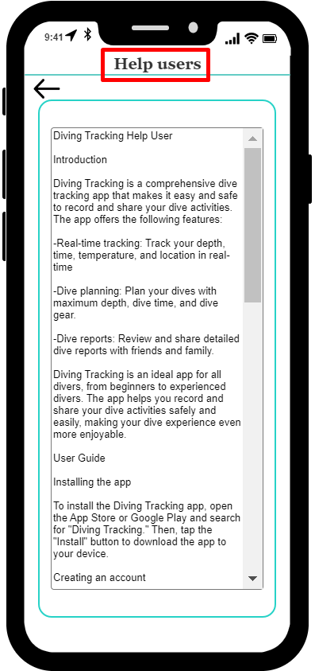

Figure 28: The interface of Help users

* **Consistency:** The position of tab icons, colors, fonts, and backgrounds are always consistent with each other in the system (Figure 29).

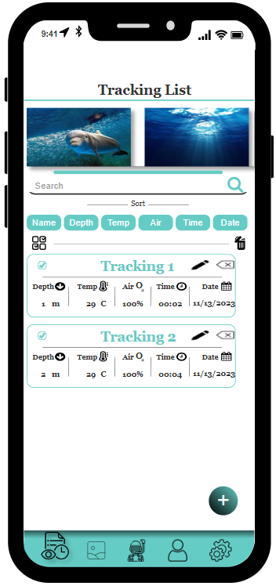 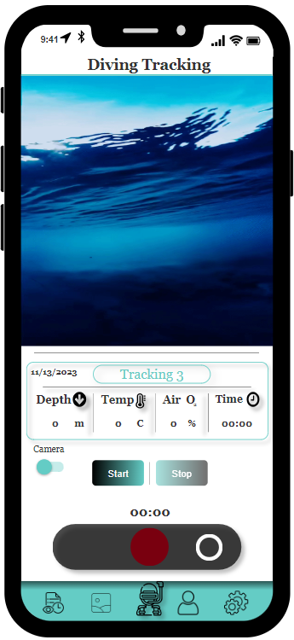

Figure 29: Demonstration of the Consistency Design Principle

# Physical Design

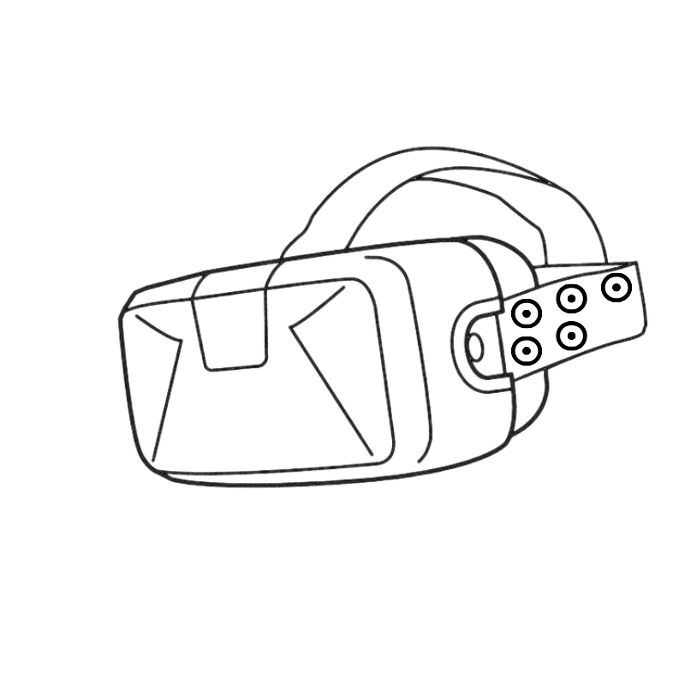

Figure 30: Physical Design (Waterproof Dive Mask)

The figure above (Figure 30) is the physical prototype of the diving tracking device. It is used to connect to the Diving Tracking application via Bluetooth. The device is worn on the diver's head, providing a comfortable and flexible fit for diving. The camera and controller are designed to be located on either side of the ear for easy interaction and control. In addition, to turn the device on or off, users simply press a button. If the device is turned on, the notification light will be green. Otherwise, when turned off, the notification light will be off. Additionally, to start, pause, or stop diving tracking on the Waterproof Dive Mask, users simply press the button on the right ear control. When tracking starts, the notification light will be blue. When paused, the notification light will be yellow. When tracking is stopped, the notification light will be red. In addition, to turn the camera on or off, users simply press the button located on the left ear control. Finally, the Bluetooth connection button for this device to other tracking data recording devices such as (smartphones or smartwatches) is also located on the left ear control.

# Research Study

To prove that the Diving Tracking app is a good, user-friendly, and easy-to-use app, we have proposed the following two hypotheses:

* **Hypotheses 1:** User-friendly Diving Tracking app interface
* **Hypotheses 2:** Diving Tracking app functionality is easy to use

**Ensuring Research Reliability and Data Accuracy: A Rigorous Approach**

In the realm of scientific inquiry, the pursuit of reliable research findings and accurate data collection holds paramount importance. This overarching principle guided our research endeavors, shaping our methodology and ensuring the validity of our conclusions. To achieve this objective, we meticulously crafted a participant selection process, employed a combination of qualitative and quantitative data collection methods, and rigorously adhered to data analysis protocols.

**Participant Selection: A Quest for Expertise and Relevance**

The cornerstone of reliable research lies in the careful selection of participants. Recognizing this, we meticulously assembled a group of seven individuals, three men and four women, all within the age range of 20 to 28 years old. These participants were not chosen arbitrarily; rather, they were specifically selected based on their extensive diving experience, ranging from one to five years. This emphasis on experience ensured that our participants possessed the necessary knowledge and skills to provide meaningful insights into the research questions at hand. To recruit these highly qualified individuals, we strategically engaged with the Diving group on Facebook, a social media platform frequented by diving enthusiasts and professionals. By actively seeking volunteers for our user study within this online community, we effectively tapped into a pool of potential participants who were not only well-versed in diving but also demonstrated a genuine interest in contributing to the advancement of diving knowledge. This recruitment strategy proved to be highly successful, resulting in a group of participants who were well-suited to provide the depth and breadth of information required for our study.

**A Blend of Qualitative and Quantitative Methods: Unravelling Complexities**

In pursuit of a comprehensive understanding of the research questions, we employed a multifaceted approach that encompassed both qualitative and quantitative data collection methods. This synergistic combination enabled us to capture a holistic perspective, delving into the nuances of the participants' experiences while quantifying key aspects of their behavior. As detailed in Table 2, three quantitative questions were formulated to gather specific, measurable data. These questions addressed aspects such as the participants' perceived ease of use of the diving equipment, their self-reported satisfaction with the training provided, and their overall enjoyment of the diving experience. By quantifying these variables, we were able to identify patterns and trends that provided valuable insights into the effectiveness of the diving program. Complementing the quantitative data, we also employed a qualitative question to capture the participants' subjective experiences and perspectives. This open-ended question allowed them to freely express their thoughts and feelings about the diving program, providing a deeper understanding of their individual motivations, challenges, and overall satisfaction.

**Data Analysis: Unveiling the Essence of Information**

Once the data was meticulously collected, we subjected it to rigorous analysis procedures, ensuring the integrity and accuracy of the findings. For the quantitative data, we employed appropriate statistical techniques to identify significant patterns and relationships between variables. This statistical analysis provided a robust foundation for drawing meaningful conclusions about the effectiveness of the diving program. The qualitative data, on the other hand, underwent a thematic analysis process, whereby we carefully coded and categorized the participants' responses to identify recurring themes and patterns. This in-depth analysis allowed us to uncover the underlying sentiments and experiences of the participants, providing a rich understanding of their perspectives.

**Conclusion: A Commitment to Rigor**

Throughout our research endeavor, we remained steadfast in our commitment to ensuring the reliability of our findings and the accuracy of the data collected. This unwavering dedication to scientific rigor guided our participant selection process, shaped our data collection methods, and informed our data analysis procedures.

Table 2: Hypothesis & Questions

|  |  |  |
| --- | --- | --- |
| **No** | **Hypothesis** | **Question** |
| 1 | User-friendly Diving Tracking app interface | 1. How long did it take you to learn how to use the app?  2. Do you find the app interface easy to see and understand?  3. Do you find the icons and text on the app easy to read?  4. Can you describe the app interface in one word or phrase? |
| 2 | Diving Tracking app functionality is easy to use | 1. Can you easily start a dive tracking?  2. Can you easily view dive tracking metrics?  3. Can you easily edit or delete dive trackings?  4. Can you describe the app functionality in one word or phrase? |

Google Forms Proved to be a valuable tool for conducting this survey. It streamline the process and minimized expenses so this coursework used it. To analyze the statistics gathered from the questionnaires, this coursework will employ circular charts. The questionnaire can be found in Appendix 1, and the results of the questionnaire analysis are provided in Appendix 2.

# Conclusion

The Diving Tracking project has successfully developed a user-friendly and reliable diving app and device that enhances the underwater exploration experience. The app and device effectively track diving activities, providing accurate information on depth, time, and air consumption. The underwater photography and video recording features enable users to capture memorable moments and share them with others. This project has demonstrated the feasibility of utilizing advanced technology to create an engaging and enjoyable diving experience.

**Limitations and Constraints:** The current prototype of the Diving Tracking device utilizes Bluetooth for communication with the mobile app. While Bluetooth provides a reliable connection, it may not have the necessary range for deep-sea diving or underwater exploration in remote locations. Additionally, the device's design could be further optimized for comfort and fit, particularly for extended diving sessions. In terms of research methodology, the study involved a relatively small sample size of seven participants. A larger and more diverse sample would provide a more comprehensive understanding of user preferences and potential areas for improvement. Additionally, incorporating feedback from experienced divers and diving instructors could further refine the app's functionality and usability.

**Areas for Improvement:** To enhance the Diving Tracking app and device, several improvements could be considered. Implementing a long-range communication technology, such as Lora WAN or Wi-Fi mesh, would extend the device's connectivity range and enable communication in remote underwater environments. Enhancing the device's design to accommodate different head sizes and shapes would improve comfort and fit, especially for extended diving sessions.

**Potential Next Steps:** The Diving Tracking project offers several promising avenues for future development. Creating a high-fidelity prototype would allow for more in-depth testing and user feedback, enabling further refinement of the app's interface and the device's design. Conducting more extensive research with a larger and more diverse sample of divers would provide a more comprehensive understanding of user needs and preferences. Additionally, exploring integration with wearable devices and diving computers could expand the app's capabilities and provide a more integrated diving experience.

# References

Buley, L., 2013. *The User Experience Team of One: A Research and Design Survival Guide.* New York: Louis Rosenfeld.

By Laura Foley. (2022). *Kelp Farming [iDiveblue] Ocean Agriculture for a Sustainable Future*. https://www.idiveblue.com/kelp-farming-for-a-sustainable-future/

Cohen, M. H., Giangola, J. P. & Balogh , J., 2004. *Voice User Interface Design.* American: Addison-Wesley.

Cooper, A., Reimann, R., Cronin, D. & Noessel, C., 2014. *About Face: The Essentials of Interaction Design.* Indianapolis, Indiana: English.

Divernet. (2020, January 15). Finding The Best Dive-Logging App. https://divernet.com/scuba-gear/finding-the-best-dive-logging-app/#Divemate

International, S. S. S., 2023. *play.google.com.* [Online]   
Available at: https://play.google.com/store/apps/details?id=com.divessi.ssi

Mark Evans. (2022). Shearwater Teric Review - Is This The Last Dive Computer You’ll Ever Purchase? https://www.scubadivermag.com/shearwater-teric-review-is-this-the-last-dive-computer-youll-ever-purchase/

Teo Yu Siang. (2020). What is Interaction Design? | IxDF. https://www.interaction-design.org/literature/article/what-is-interaction-design

Jewitt, C. et al., 2019. *Interdisciplinary Insights for Digital Touch Communication.* Cham, Switzerland: Springer International Publishing.

Knoch, S., 2023. *play.google.com.* [Online]   
Available at: https://play.google.com/store/apps/details?id=com.divinglog.divelog

Norman, D., 2002. *The design of everyday things.* New York: Basic Books.

Research, P., 2023. *play.google.com.* [Online]   
Available at: https://play.google.com/store/apps/details?id=com.sealife.sportdiver

Rogers, Y., 2012. *HCI Theory: Classical, Modern, and Contemporary.* UK: Morgan & Claypool Publishers.

Roth, I. & Frisby, J. P., 1986. *Perception and Representation: A Cognitive Approach.* Maidenhead, Berkshire, United Kingdom: Open University Press.

Schuler, D. & Namioka, A., 1993. *Participatory design: principles and practices.* United States of America: Routledge.

Sharp, H., Rogers, Y. & Preece, J., 2019. *Interaction design beyond human-computer interaction.* Indianapolis, Indiana: Wiley.

# Appendices 1 - The questionnaires in the Diving Tracking project’s survey

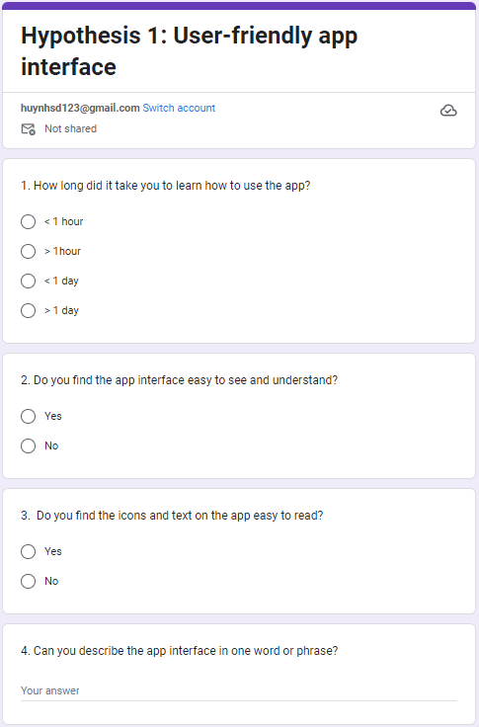

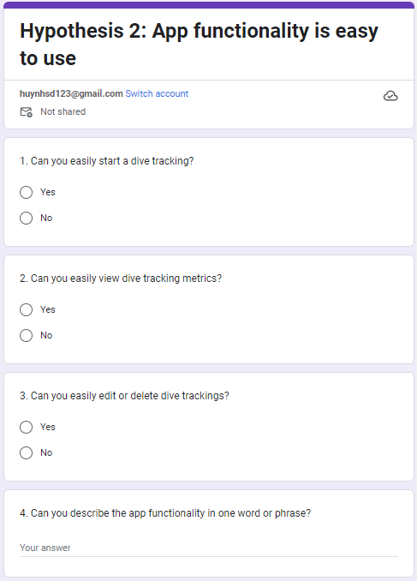

# Appendices 2 - Analyze the results of the questions in the survey and draw conclusions for each hypothesis that has been raised.

* **This is survey link of Hypothesis 1:**

<https://docs.google.com/forms/d/e/1FAIpQLScfUGRedRxGN0l40bt8ystx8gzjMBML52wQMmyGd8bgpjLTSQ/viewform>

Analysis of the survey results of **Hypothesis 1:** **User-friendly Diving Tracking app interface**

* **Result of question 1:** The results of the survey show that 86% of the participants were able to learn how to use the application within one day. This is a positive result, indicating that the application has a user-friendly interface and learning curve. However, 14% of the participants took more than one day to learn how to use the application (Figure 31).

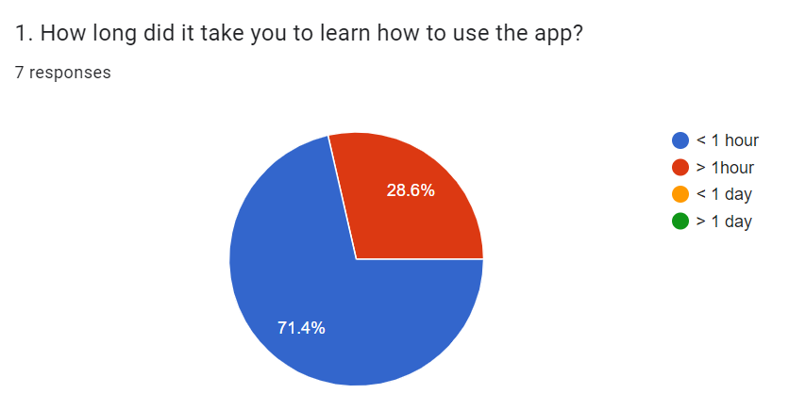

Figure 31: Question 1 of Hypothesis 1

* **Result of question 2:** The pie chart shows the results of a survey on whether people find the app interface easy to see and understand. The chart shows that 100% of respondents found the interface easy to see. This suggests that the app interface is visually appealing and easy to navigate (Figure 32).

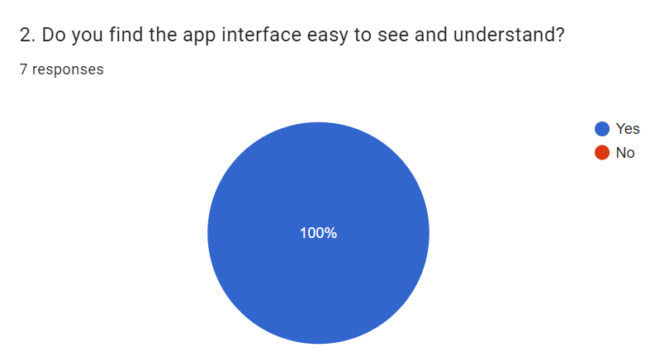

Figure 32: Question 2 of Hypothesis 1

* **Result of question 3:** The pie chart shows that 100% of respondents found the app interface easy to read, This suggests that the interface is generally well-designed and easy to use (Figure 33).

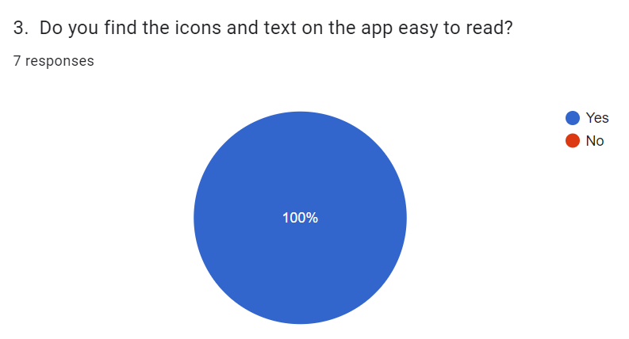

Figure 33: Question 3 of Hypothesis 1

* **Result of question 4:** The most common responses are "good" and "very good," which suggests that overall, people are satisfied with the app interface. The other responses, such as "amazing," "nice," "cool," "awesome," and "so cool," suggest that people are particularly impressed with the interface. The fact that the seven responses are all positive suggests that the app interface is well-designed and easy to use. The use of simple, clear language and graphics makes the interface easy to understand and navigate. The colors and fonts are also well-chosen and create a visually appealing interface (Figure 34).

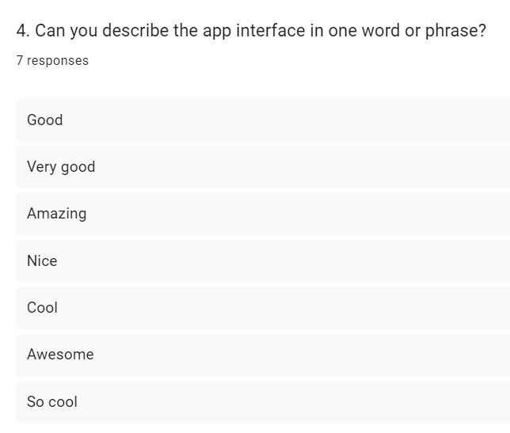

Figure 34: Question 4 of Hypothesis 1

**Conclusion:** The results of the survey strongly support the hypothesis that the Diving Tracking app interface is user-friendly. The majority of respondents were able to learn how to use the application within one day, and all respondents found the interface easy to see, read, and understand. Additionally, the most common responses to a question about the overall satisfaction with the interface were "good" and "very good." These results suggest that the Diving Tracking app interface is well-designed, easy to use, and visually appealing.

* **This is survey link of Hypothesis 2:**

<https://docs.google.com/forms/d/e/1FAIpQLSd1BZz5Po_fmA3sHudlczyxka06bCxWbYysWSbg1zXhNFbRYw/viewform>

Analysis of the survey results of **Hypothesis 2:** **Diving Tracking app functionality is easy to use**

* **Result of question 1:** The survey was conducted with 7 participants, with the question: "Were you able to easily start tracking your trip?". The results show that 100% of participants answered "yes" (Figure 35).

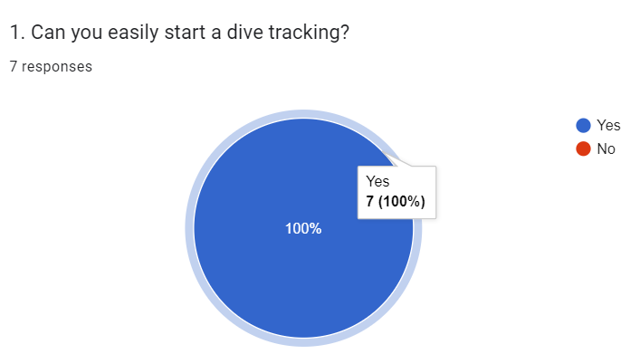

Figure 35: Question 1 of Hypothesis 2

* **Result of question 2:** The survey results are positive overall, with 100% of participants indicating that they were able to easily view the tracking metrics (Figure 36).

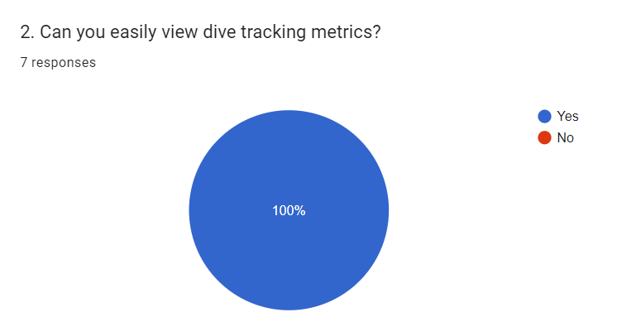

Figure 36: Question 2 of Hypothesis 2

* **Result of question 3:** The survey results are positive overall, with 100% of participants indicating that they were able to easily edit or delete tracking records. This suggests that the application/website interface is well-designed and easy to use (Figure 37).

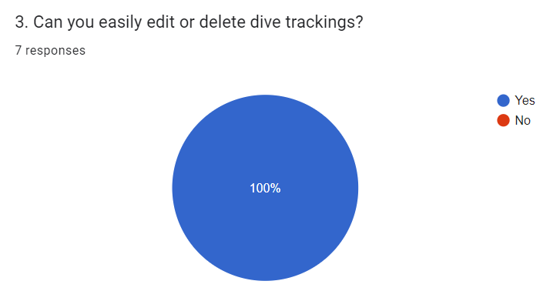

Figure 37: Question 3 of Hypothesis 2

* **Result of question 4:** The survey results are positive overall, with 100% of participants indicating that they were able to easily edit or delete tracking records. This suggests that the application/website interface is well-designed and easy to use (Figure 38).

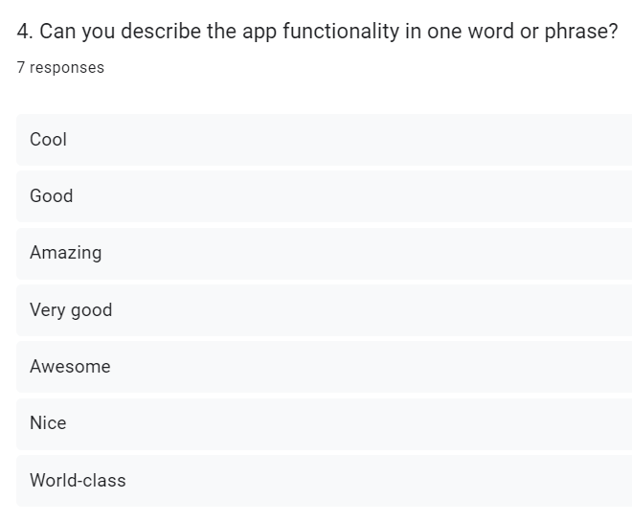

Figure 38: Question 4 of Hypothesis 2

**Conclusion:** Based on the provided survey results, it is evident that the Diving Tracking app offers a user-friendly interface that allows users to effortlessly perform various tasks related to tracking their diving activities. With 100% of participants indicating ease of use in starting trip tracking, viewing tracking metrics, and editing or deleting tracking records, it is clear that the app's functionality is intuitive and straightforward. These findings strongly support the conclusion that the Diving Tracking app functionality is easy to use, making it an accessible and convenient tool for divers of all levels.

# Appendices 3 - Ten heuristics for user interface design outlined by Nielsen

**For the implementation of the Diving Tracking project, this project employed ten heuristics for user interface design outlined by Nielsen** (Nielsen, 2020)**:**

* **Visibility of system status**: In the Profile interface, when the user enters their name and clicks the Save button, the application will save the user's name to the system and display an immediate notification on the interface (Figure 39).

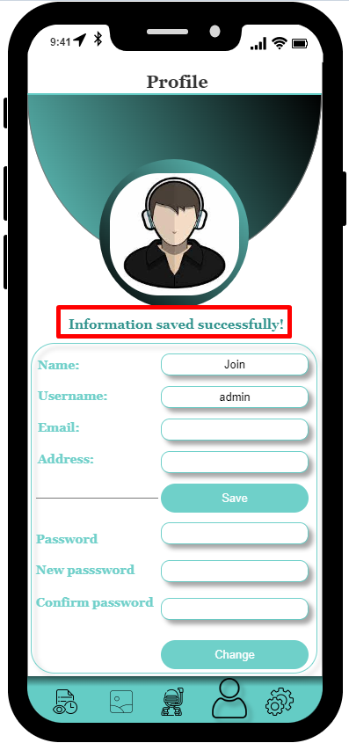

Figure 39: Visibility of system status of Diving Tracking project

* **Match between system and the real world:** The icons used in the application are consistent with the real world (Figure 40).

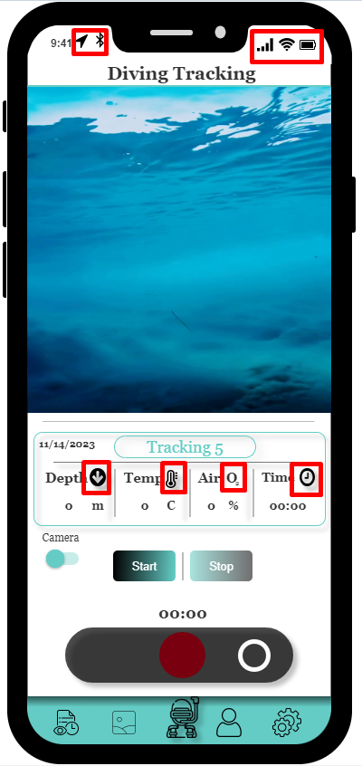

Figure 40: Match between system and the real world of Diving Tracking project

* **User control and freedom:** When a user clicks on the Select All icon, all tracking will be checked. However, when the user clicks again, all tracking will be unchecked (Figure 41 and 42).

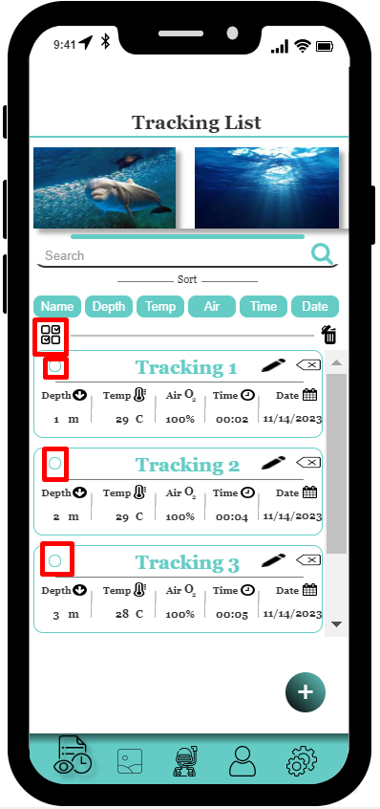

Figure 41: User control and freedom of Diving Tracking project

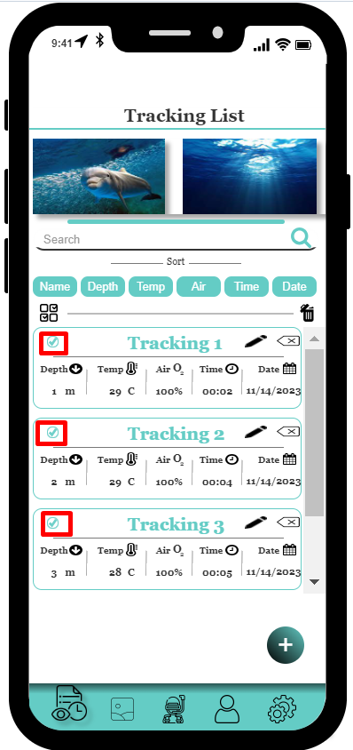

Figure 42: User control and freedom of Diving Tracking project

* **Consistency and standards:** All tab icons have the same size and format (Figure 43 and 44).

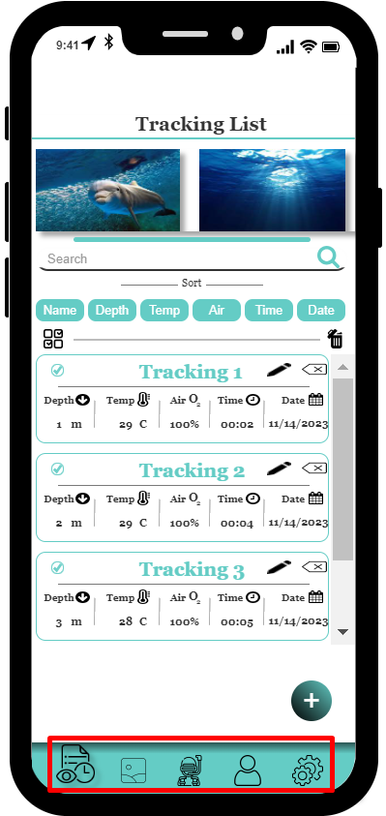

Figure 43: Consistency and standards of Diving Tracking project

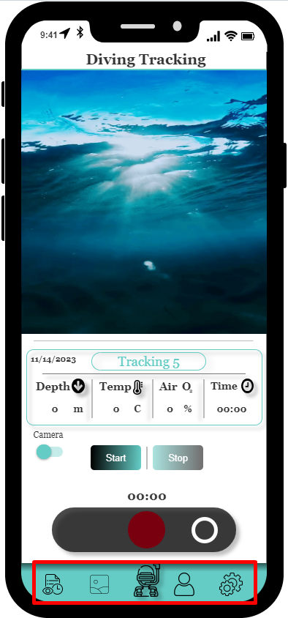

Figure 44: Consistency and standards of Diving Tracking project

* **Error prevention:** When registering for an account, the application requires users to enter a confirm password to ensure the accuracy of the password (Figure 45 and 46).

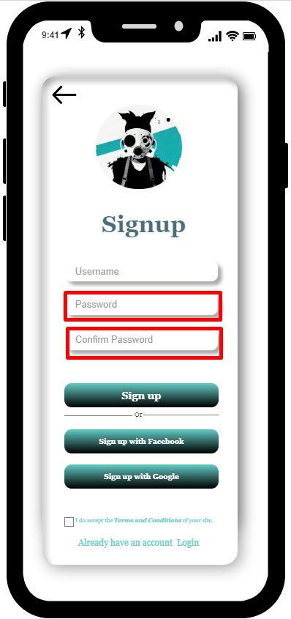

Figure 45: Error prevention of Diving Tracking project

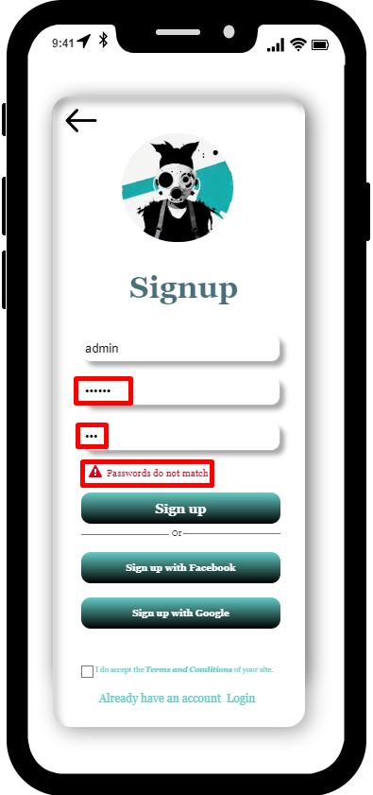

Figure 46: Error prevention of Diving Tracking project

* **Recognition rather than recall:** When a user adds a new tracking, the application will automatically name the tracking without the user having to remember what number tracking it is in the list (Figure 47 and 48).

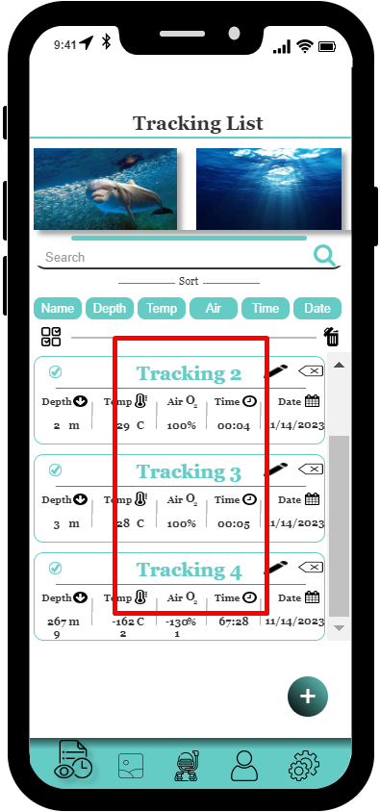

Figure 47: Recognition rather than recall of Diving Tracking project

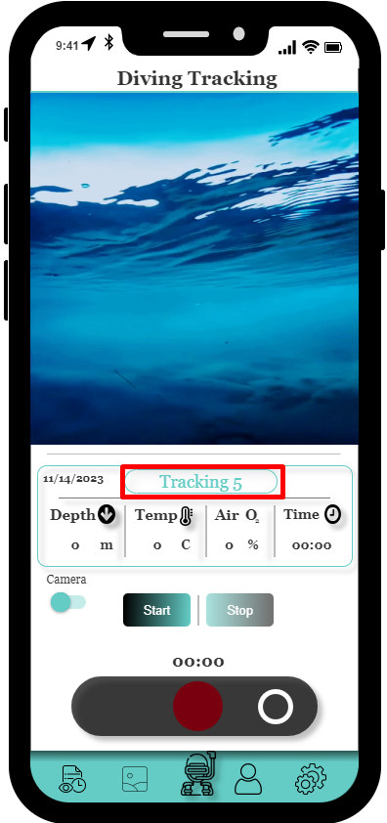

Figure 48: Recognition rather than recall of Diving Tracking project

* **Flexibility and efficiency of use:** In the Settings interface, users can enable or disable the conversion of depth or temperature units (Figure 49, 50, 51, and 52).

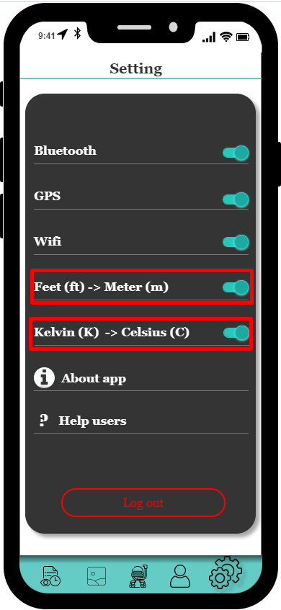

Figure 49: Flexibility and efficiency of use of Diving Tracking project, turn on the feet-to-meter and kelvin-to-celsius conversion modes

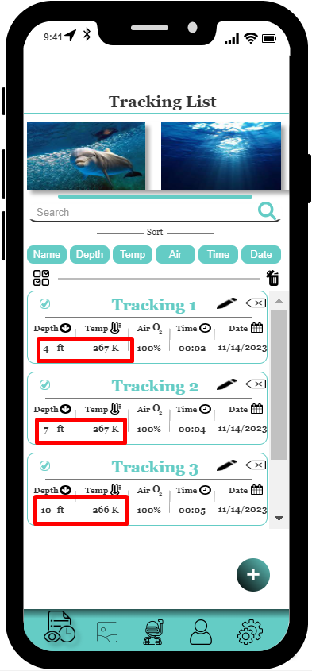

Figure 50: Flexibility and efficiency of use of Diving Tracking project, turn on the feet-to-meter and kelvin-to-celsius conversion modes

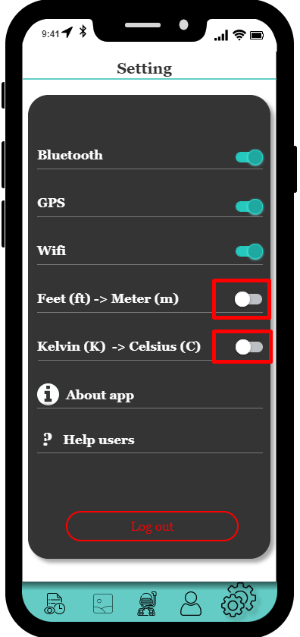

Figure 51: Flexibility and efficiency of use of Diving Tracking project, turn off the feet-to-meter and kelvin-to-celsius conversion modes

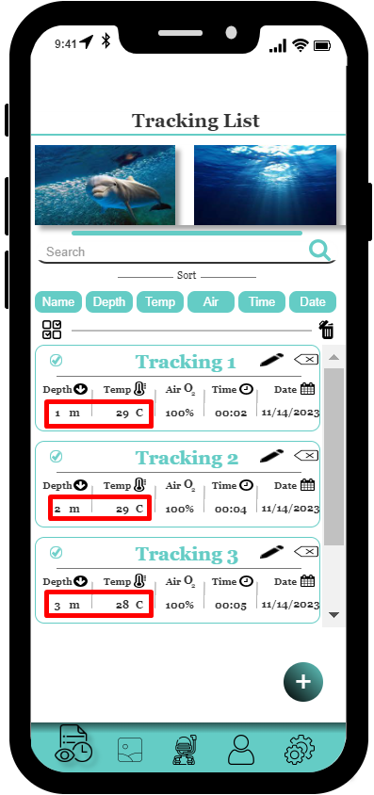

Figure 52: Flexibility and efficiency of use of Diving Tracking project, turn off the feet-to-meter and kelvin-to-celsius conversion modes

* **Aesthetic and minimalist design:** The colors and fonts of the application are displayed in a harmonious way (Figure 53).

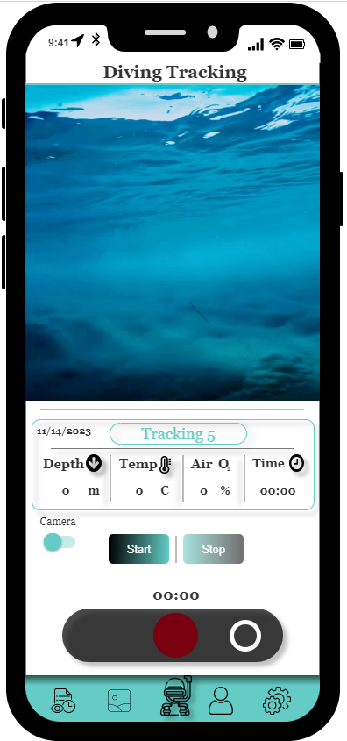

Figure 53: Aesthetic and minimalist design of Diving Tracking project

* **Help users recognize, diagnose, and recover from errors:** When a user logs in, if the user enters the wrong password or account, the application will display an error message and ask the user to try again (Figure 54).

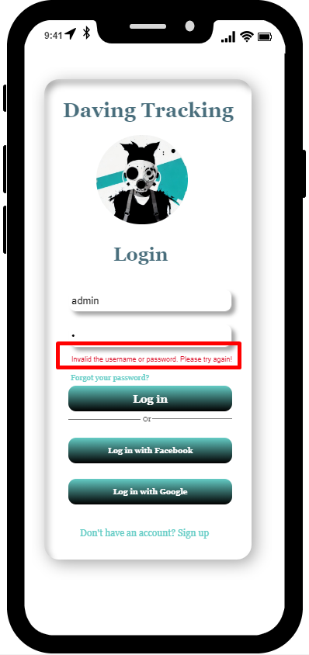

Figure 54: Help users recognize, diagnose, and recover from errors of Diving Tracking project

* **Help and documentation:** This programme contains a Help area where users may get useful information while using it (Figure 55 and 56).

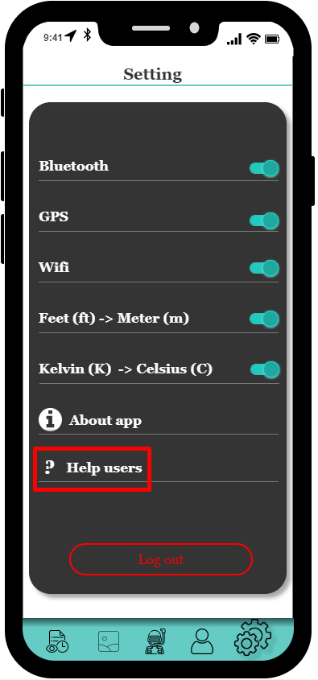

Figure 55: Help and documentation of Diving Tracking project

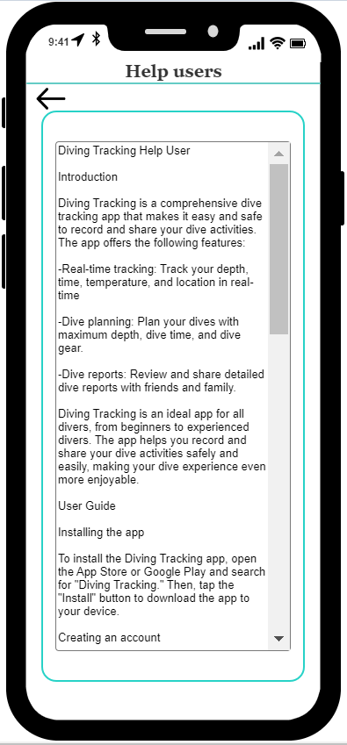

Figure 56: Help and documentation of Diving Tracking projec

1. iDiveblue: https://www.idiveblue.com/
2. Shearwater Teric: https://www.shearwater.com/about/
3. DiveMate: https://www.divemate.de/